0

MScFE 652 Portfolio Management

GROUP WORK PROJECT 1

Student Group 6545

Tchawou Francky Kevin

Prasanna Seshadri

Wei Wee Law

**Table of Contents**

|  |  |
| --- | --- |
| **Step 1: Definition of Fama/French 5 Factors** | **3** |
| A) Market Risk Premium (Rm - Rf) | 3 |
| B) Small Minus Big (SML) | 4 |
| C) High Minus Low (HML) | 5 |
| D) Conservative Minus Aggressive (CMA) | 6 |
| E) Robust Minus Weak (RMW) | 7 |
| **Step 2 Study on Fama/French 5 Factor Daily Data** | **8** |
| Step 2a: Representation of FF5 Factors Daily Data Trend | 8 |
| Step 2b: Correlation between the change in FF5 Factor Returns | 8 |
| Step 2c: Representation of Economic Data | 9 |
| **Step 3 Study on FF3 Beta Coefficient** | **10** |
| **Step 4 Study on FF5 Beta Coefficient** | **10** |
| **Step 5 Empirical Study on FF3 and FF5 Daily Factor Returns** | **11** |
| **Step 6 Improvement from FF5 to FF3** | **11** |
| **Step 7 Markowitz Portfolio Optimization** | **12** |
| **Step 8 Result and Interpretation** | **15** |
| **References** | **1**6 |

***This summary report consists of 10 pages from Page 3 to Page 13, excluding cover page, table of contents and reference.***

# Step 1: Definition of Fama/French 5 Factors

**A) Market Risk Premium (Rm - Rf)**

**Technical**

Rm-Rf is a critical component of the Capital Asset Pricing Model (CAPM) and represents Market Risk Premium. CAPM is a way to predict expected return on a certain stock based on Beta i.e. systematic risk (how does your stock correlate with the Market). Beta is the standardized measure of the covariance of the assets return with the market return. β represents the asset's sensitivity to market movements.

In the CAPM, the expected return of an asset is calculated using the formula:

𝐸𝑥𝑝𝑒𝑐𝑡𝑒𝑑𝑅𝑒𝑡𝑢𝑟𝑛 = 𝑅𝑓+×(𝑅𝑚**−**𝑅𝑓)

𝑅𝑚−𝑅𝑓 is Market Risk Premium (MRP), instead from risk free assets the return that investors expect to earn from holding a risky market portfolio. It is the difference between the return on the market portfolio (Rm) and the risk-free rate (Rf). MRP (𝑅𝑚−𝑅𝑓) is a crucial input that affects the expected return based on the asset's risk relative to the market. The magnitude of this MRP is influenced by different factors (economic conditions, sentiment of investors, risk environment overall).

Rm typically is represented by a broad market index (such as S&P 500) and reflects overall performance of the equity market. RF is the return on an investment with 0 risk, often represented by stable securities virtually free of default risk such as US Treasury bills.

**Non-Technical**

Investors can make more informed decisions about where to allocate their capital by comparing the expected return of an asset to the Market Risk premium (𝑅𝑚−𝑅𝑓).

We all understand the concept of risk vs. reward. For bearing systematic risk which cannot be diversified, for taking on the risk of investing in the market as a whole, investors expect to be rewarded. Reflecting the overall market sentiment and economic conditions MRP provides a benchmark for assessing the risk and return of individual assets or portfolios.

**B) Small Minus Big (SML)**

**Technical**

Small Cap Outperform large Cap (Size Effect)

Farma and French expanded CAPM and added size effect (Small minus Big) to the formula and Value of stock (High minus Low).

In CAPM, we are using one factor model to calculate expected return. Expected Return =𝑅𝑓 +  × (𝑅𝑚**−**𝑅𝑓) Farma-French Model expands CAPM and adds SMB (size of the stock) and HML (value of the stock). Expected Return = = 𝑅𝑓 +  × (𝑅𝑚**−**𝑅𝑓) + SMB + HML

Small Minus Big (SMB) is a factor that captures size effect, measures the additional return investors have historically received by investing in small-cap stocks compared to large-cap stocks. Smaller firms tend to outperform larger firms over the long term as analysts pay close attention to large firms and information is efficient compared to small firms. SMB is calculated by taking the difference in returns between a portfolio of small-cap stocks and a portfolio of large-cap stocks.

**Non-Technical**

Small minus big (SMB), it is a small capitalization. Looking at small cap stocks vs. large cap stocks, for example Apple computer has large capitalization 1 Trillion (of shares * stock market price) and Papa Jones (1.42 Billion). Analysts follow large cap stocks closely like Apple more than Papa JOnes, better informed investors with media coverage, the prices of large cap stocks reflects true value and they are less susceptible, less systematic risk, systematic markets, everything is known because they are followed as everyone is evaluating them and we have more information about large caps, more info, less risk.

Shares of large firms may be less risky than those of small firms, other things being equal, as they are covered by more analysts, and there is more accurate information about them. With better-informed investors, prices will more accurately reflect true value and be less susceptible to systematic as well as firmspecific fluctuations. Shares of large firms with deeper pockets and greater debt capacity, large firms also can better withstand economic downturns. Because of both above reasons, small firms will command higher risk premiums than indicated by beta alone.

By including SMB in a model, enhancing the explanatory power of the model in predicting asset returns, investors can account for the additional return that small-cap stocks provide.

**C) High Minus Low (HML)**

**Technical**

HML is one of the supplemental and irregular factors added to CAPM with SML (explained in the previous section), established under the Fama-French 3 Factor model. HML, or known as High-minus-Low is used to measure the return difference between the portfolio with high Book-to-Market (BM) value and portfolio with small BM (Fama & French, 1995). In FF3 model equation, the factor return of HML is expected premium, accompanied with factor loading known as hi. Researchers believe that the inclusive of SML and HML can provide more comprehensive prediction on expected return (Fama & French, 1996)

For HML factor return, it can be calculated as per the equation below (Tarek & Suret, 2004), ℎ 𝐻𝑀𝐿 where *ℎ* is factor loading

HLM can also be expressed in the following equation:

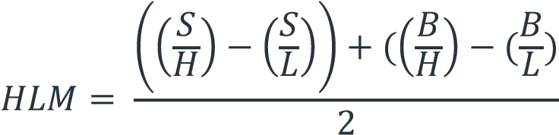

The symbol representations are: B and S (Big and Small Sizes in relative to Market Equity) H and L (High and Low Book-to-Market (BM)); where H corresponds to 70% or higher of BM breakpoints, and L corresponds to 30% or lower of BM breakpoints.

The equation above also represents an equally weight average of the return on the value portfolio minus on the growth portfolio. S/H, S/L, B/H and B/L are also known as intersection of size and Book-to-Market groups. Other researchers also define HML as the return differential between the average value and the average growth portfolios.

**Non-Technical**

Fama and French discovered that firms with high BM and positive slopes on HML is generally low performed companies (or known as glamor stocks), and good performed companies generally has low BM and negative slopes on HML (Fama & French, 1995). Therefore, the future expected return of low performed companies is higher than good performed companies that leads to compensation of owning a high-risk asset. (Fama & French, 1996)

Some researchers also suggested that several characteristics such has book to market value, earning ratio and post sales growth ratio are fall under HML (Kumar & Sehgal, 2004)

However, solely relying on SMB and HML might not be comprehensive enough to predict a robust expected return, as it may miss out those low expected return of small companies that they could not be ignored due to continuous large investment amount from public, even the profitability is low (Fama & French, 2014).

Additional factor will be explained in the following section.

1. **Conservative Minus Aggressive (CMA)**

**Technical**

CMA (Conservative Minus Aggressive) is one of the two factors added by farma-french to the three-factor FF3 model to form the five-factor FF5 model. It is about investment. It represents the average return of two conservative investment portfolios minus the average return of two aggressive investment portfolios. In other words, it reflects the difference between the returns on diversified portfolios of shares in lowinvestment and high-investment companies, which we call conservative and aggressive.

**Non-Technical**

An investment with a low CMA per event means that the reinvestment ratio is low per event A portfolio with positive CMA exposure will therefore tend to outperform when conservative companies outperform aggressive ones, which is very often the case in periods of low economic growth or high risk.

1. **Robust Minus Weak (RMW)**

**Technical**

Robust Minus Weak (RMW): The gross profitability factor captures the relative performance of companies with high profitability compared to those with low profitability. This factor can be considered as a special version of the value strategy based on gross profitability, so exposure to this factor can in fact represent the deviation of the share price from value. In other words, it is the average return of the two portfolios with strong operating profitability minus the average return of the two portfolios with weak operating profitability.

**Non-Technical**

It should be noted that portfolios with positive exposure to RMW will tend to outperform when companies with high profitability outperform those with low profitability. This very often reflects good management and financial resilience.

# Step 2 Study on Fama/French 5 Factor Daily Data

**Step 2a: Representation of FF5 Factors Daily Data Trend**

In this section, we have imported the Fama French 5 Factor Historical Daily Data found from Professor French’s website, and structure it with graph presentation as follow:

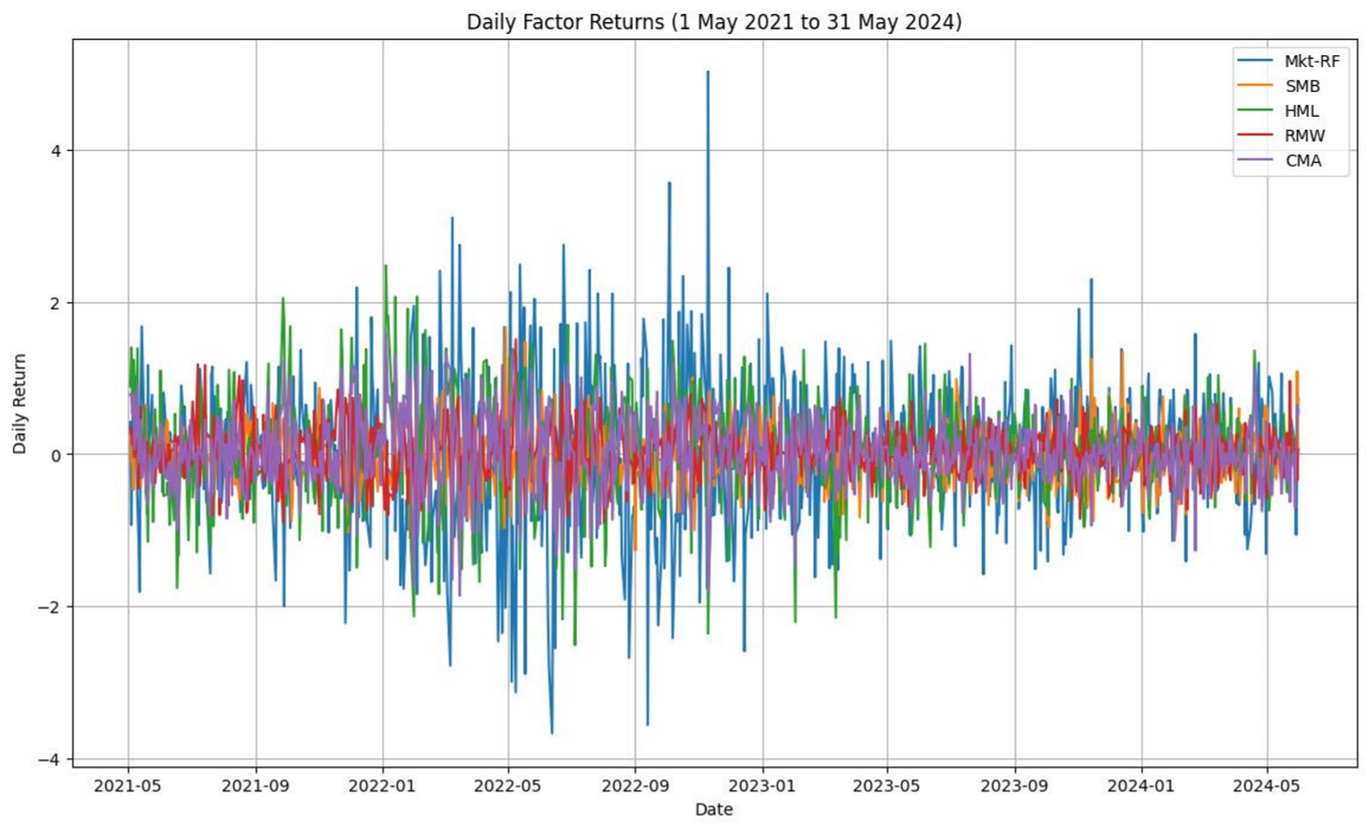

Figure 2.1.1 Graph of Daily Factor Return across 3-years Period

Based on the graph above, we have presented the historical factor trends from 1 May 2021 to 31 May 2024 (3 years period). We can notice the Market Risk Premium (Mkt-Rf) is volatile between the period of Feb 2022 to Jan 2023. It might be due to the impact of COVID-19, when most of the stock markets were moving volatile. Generally, we can notice other factors are not changing vigorously throughout the period.

**Step 2b: Correlation between the change in FF5 Factor Returns**

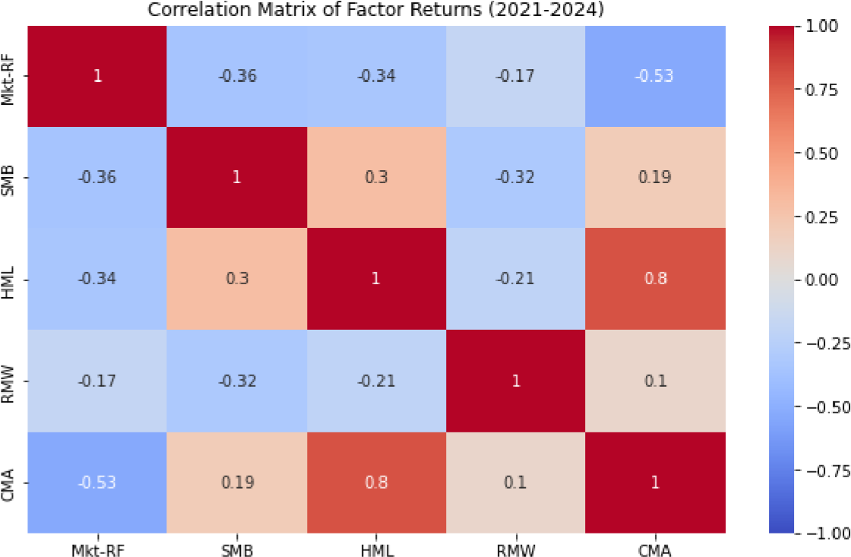

Figure 2.2.1 Correlation Matrix of the Change in Factor Return

First, we noticed HML and CMA are well correlated with 0.8. As defined in Step 1, HML and CMA represent Value Factor and Investment Factor respectively. The high positive correlation value shows the positive relationship on the characteristic of a firm. Example, for a highly valued firm, it will focus on conservative investment, instead of approaching aggressively by having risky assets.

On the other than, we noticed a negative correlation value between Mkt-RF and CMA. It means that risker investment always produce negative market risk premium, or negative return.

**Step 2c: Representation of Economic Data**

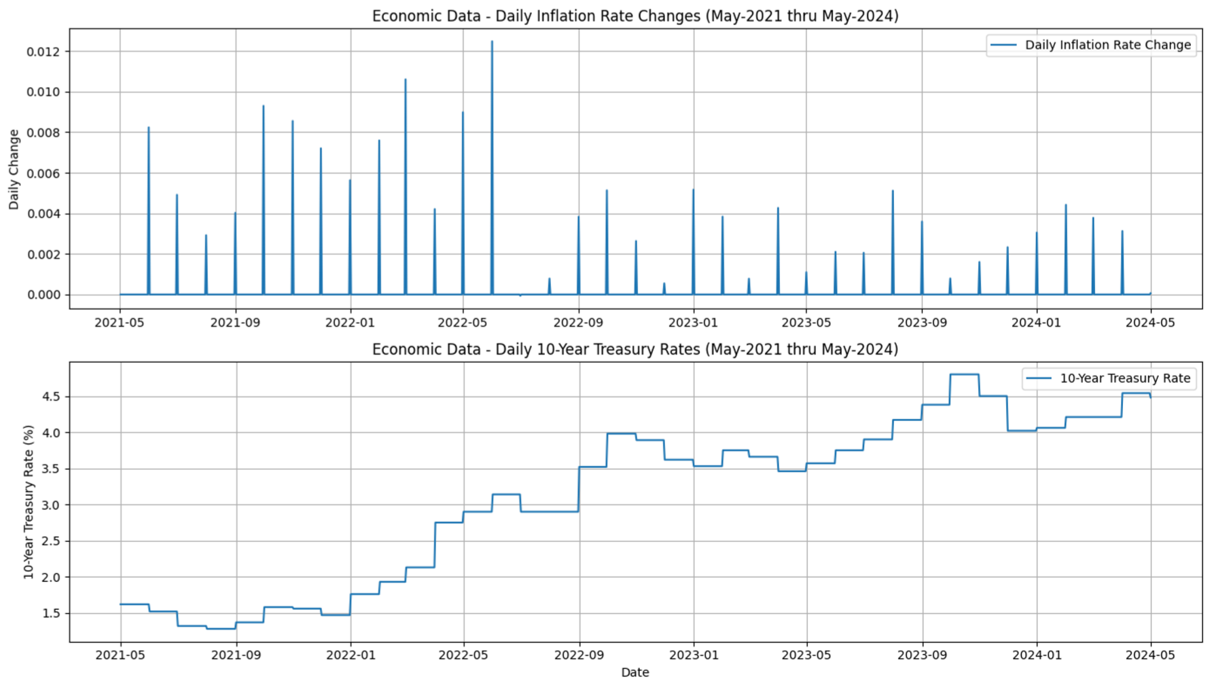

Figure 2.3.1 Daily Inflation Rate and 10-Years Treasury Rates (3 Years Period)

# Step 3 Study on FF3 Beta Coefficient

To calculate the coefficient, we should refer to the following equation:

𝑅𝑖−𝑅𝑓 = 𝛼𝑖+1 (𝑅𝑚−𝑅𝑓) + 2𝑆𝑀𝐵+3𝐻𝑀𝐿

Where  is the intercept and  is the coefficient or known as factor loading.

Based on the equation above, we have imported Fama/French 3 Factors (Daily) and 6 Portfolio (2x3) Daily for our studies. From the portfolio dataset, we also choose SH (Small size and high book-to-market value) portfolio. Using OLS and Robust Regression, we have found out the coefficient (Factor Loading), as well as its corresponding p-value. The tabulation is shown as follow:

|  |  |  |  |  |
| --- | --- | --- | --- | --- |
| **Coefficient** | **OLS** | **OLS’s P-values** | **Robust** | **Robust’s P-Values** |
| Mkt-RF | 0.623 | 0.00 | 0.625 | 0.00 |
| SMB | 0.360 | 0.00 | 0.374 | 0.00 |
| HML | 0.363 | 0.00 | 0.354 | 0.00 |

We noticed the p-values is less than 0.05 (95% confidence level), which prove that the result is statistically significant, and the null hypothesis is rejected. We can claim that the coefficient derived from both regression is close to real. Furthermore, we can notice the value derived from both regression is close. It explains that the dataset we used are not biased by the outliers.

# Step 4 Study on FF5 Beta Coefficient

Similar to Step 4, we are using same portfolio dataset, but Fama/French 5 Factors (Daily) is used to find out the coefficients of FF5 model. Using OLS and Robust Regression, we have found out the coefficient (Factor Loading), as well as its corresponding p-value. The tabulation is shown as follow:

|  |  |  |  |  |
| --- | --- | --- | --- | --- |
| **Coefficient** | **OLS** | **OLS’s P-values** | **Robust** | **Robust’s P-Values** |
| Mkt-RF | 0.973 | 0.00 | 0.975 | 0.00 |
| SMB | 0.796 | 0.00 | 0.795 | 0.00 |
| HML | 0.403 | 0.00 | 0.409 | 0.00 |
| RMW | -0.017 | 0.19 | -0.014 | 0.244 |
| CMA | -0.040 | 0.01 | -0.044 | 0.00 |

The key point that we noticed the p-values of RMW is more than 0.05 (95% confidence level), which shows no enough evidence to conclude the result is not statistically significant. It may due to the dataset of RMW contains noise. Further studies can be considered in future to find out the sensitivity and robustness of the data.

# Step 5 Empirical Study on FF3 and FF5 Daily Factor Returns

In this section, we have computed the correlation and covariance matrix for both FF3 and FF5 daily factor

return.

Some key fi

ndings from the chart above:

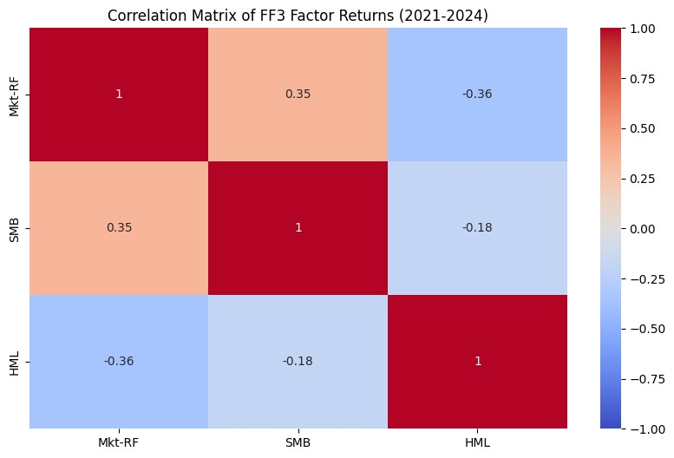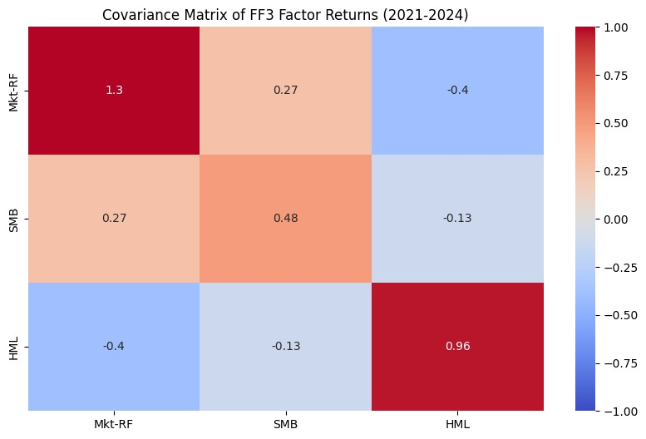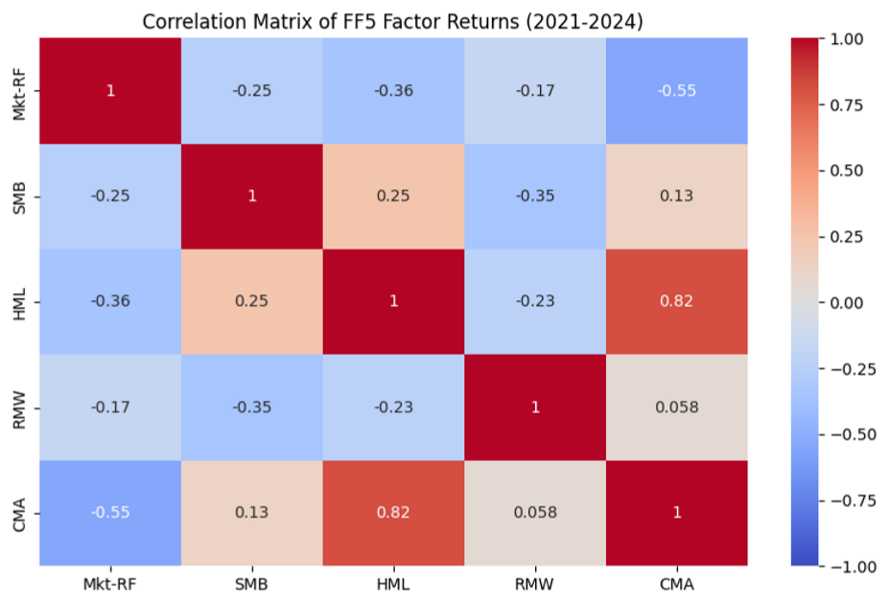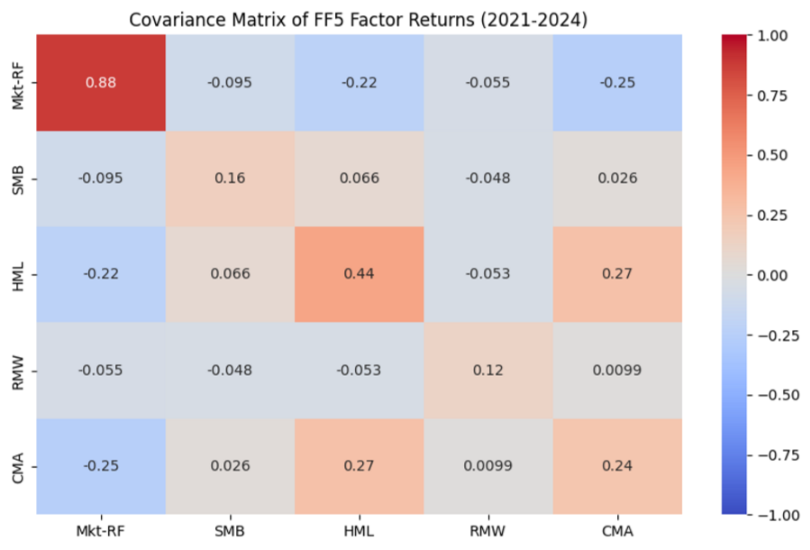

1. By adding RMW and CMA, we noticed the correlation of Mkt-RF/SMB and SMB/HML are changed, from positive to negative.
2. In FF5, we noticed RMW does not have significant correlation with CMA (0.058).
3. The strongest correlation is HML/CMA, that aligns with our interpretation in Step 2b.
4. By adding RMW and CMA, the covariance between Mkt-RF, SMB and HML are reduced, showing the impact to the change in return is reduced by additional factor return from FF5.
5. The significant covariance value is Mkt-RF/CMA and HML/CMA, that aligns to our interpretation in Step 2b.

# Step 6 Improvement from FF5 to FF3

|  |  |  |  |  |
| --- | --- | --- | --- | --- |
|  | OLS_FF3 | OLS_FF5 | Robust_FF3 | Robust_FF5 |
| R-Squared | 0.810 | 0.990 | 0.811 | 0.990 |
| Mean Square Valiue (MSE) | 0.149 | 0.007 | 0.149 | 0.007 |

Based on table above, we can notice the R-squared is increased from FF3 to FF5. It explains that prediction performance by the derived coefficient has improved. On the other hand, we also notice the MSE reduced from FF3 to FF5. The prediction by FF5 has lesser error between observed/tested and predicted values by training set. Furthermore, we can observe the value of OLS and Robust regression are almost similar, in line with our interpretation in previous section on the absence of outliers in dataset.

With the additional factor return, we can conclude that performance of the model has improved, with the increase in prediction accuracy and decrease in prediction error.

# Step 7 Markowitz Portfolio Optimization

In this section, our main objective is to find out the optimal allocation based on the 5 stocks that we have chosen. There are AAPL(Apple), PZZA (Papa Jones Pizza), MSFT (Microsoft), AMZN (Amazon) and TSLA (Tesla). Next, we have created the portfolio with maximum Sharpe ratio among these 5 stocks and the optimal allocation is shown as follow:

|  |  |  |  |  |  |
| --- | --- | --- | --- | --- | --- |
| Ticker | AAPL | PZZA | MSFT | AMZN | TSLA |
| Optimal Portfolio Weights % | 42.32% | 27.05% | -8.02% | -0.39% | 39.04% |

Note: risk free rate used as 0.01, in finding optimal portfolio

Next, we have aligned the portfolio return to the FF3 and FF5 models, and run the OLS/Robust

regression to check their dependency.

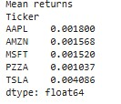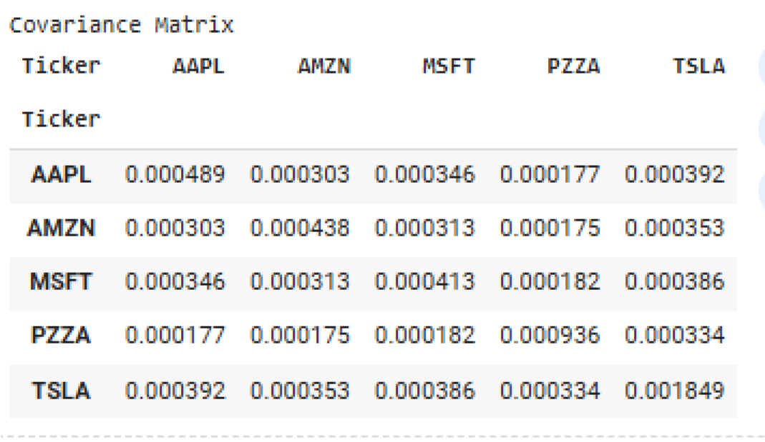

FF3 Results:

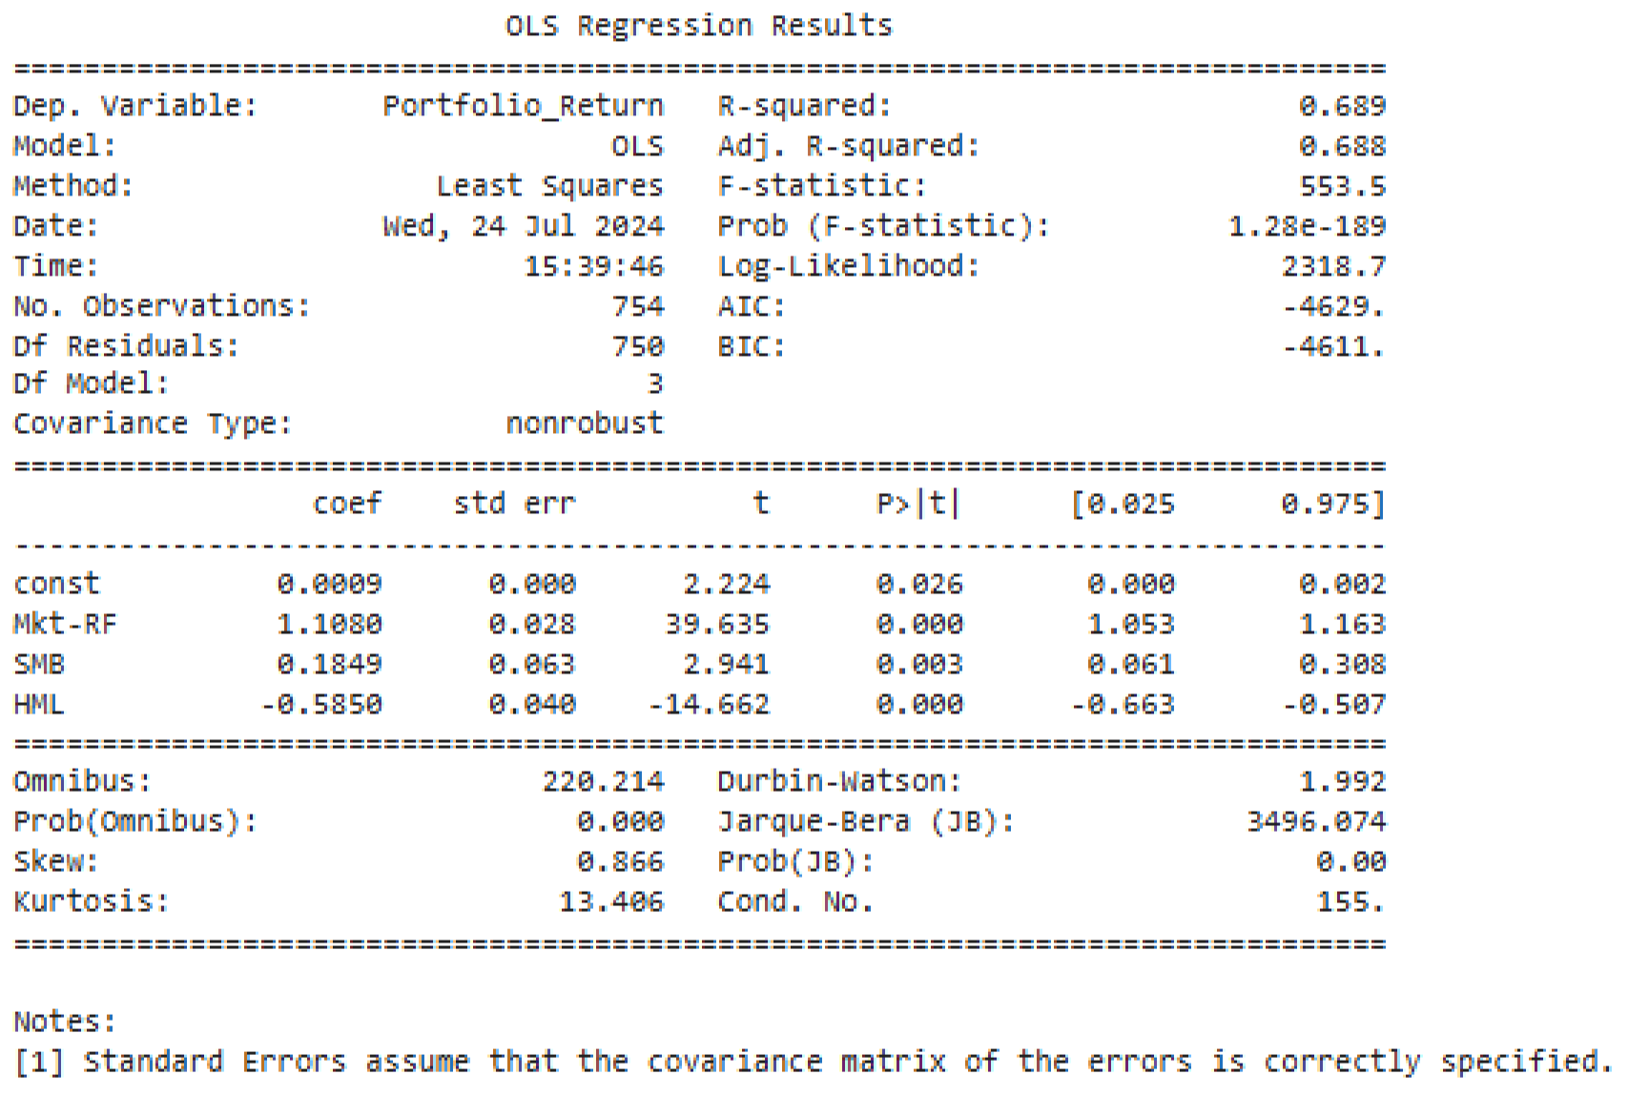

FF5 Results:

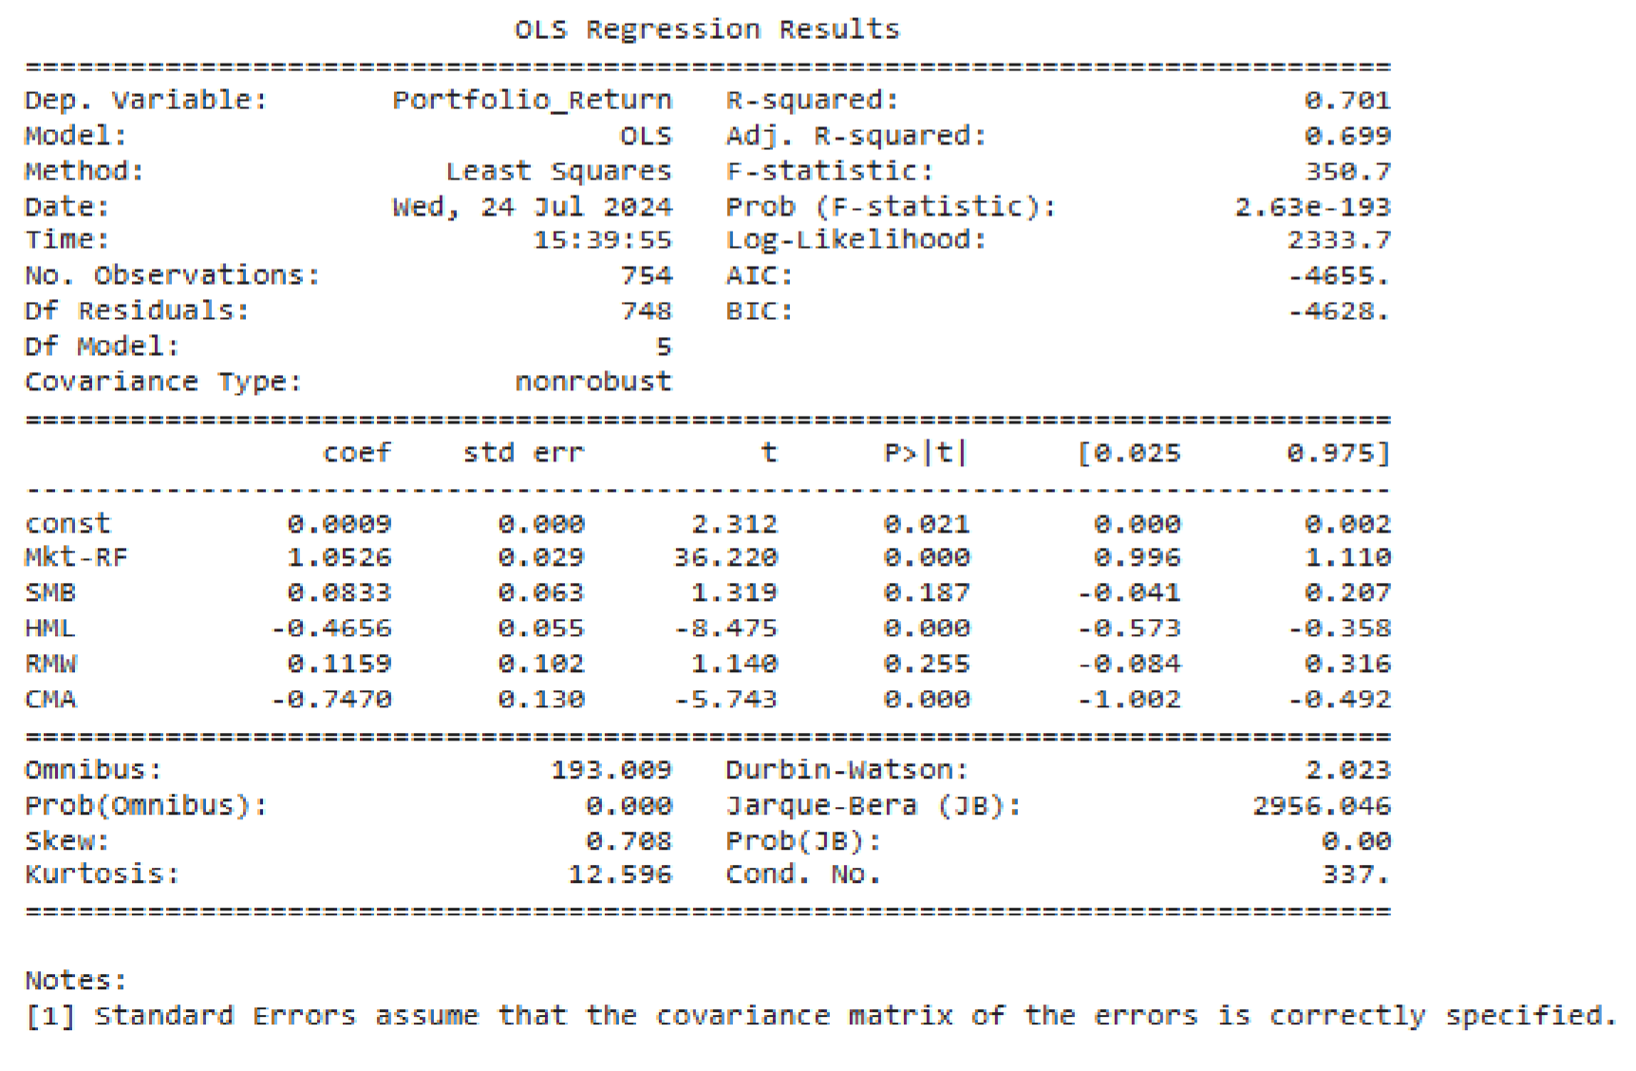

Efficient Frontier generated with 5000 random portfolios

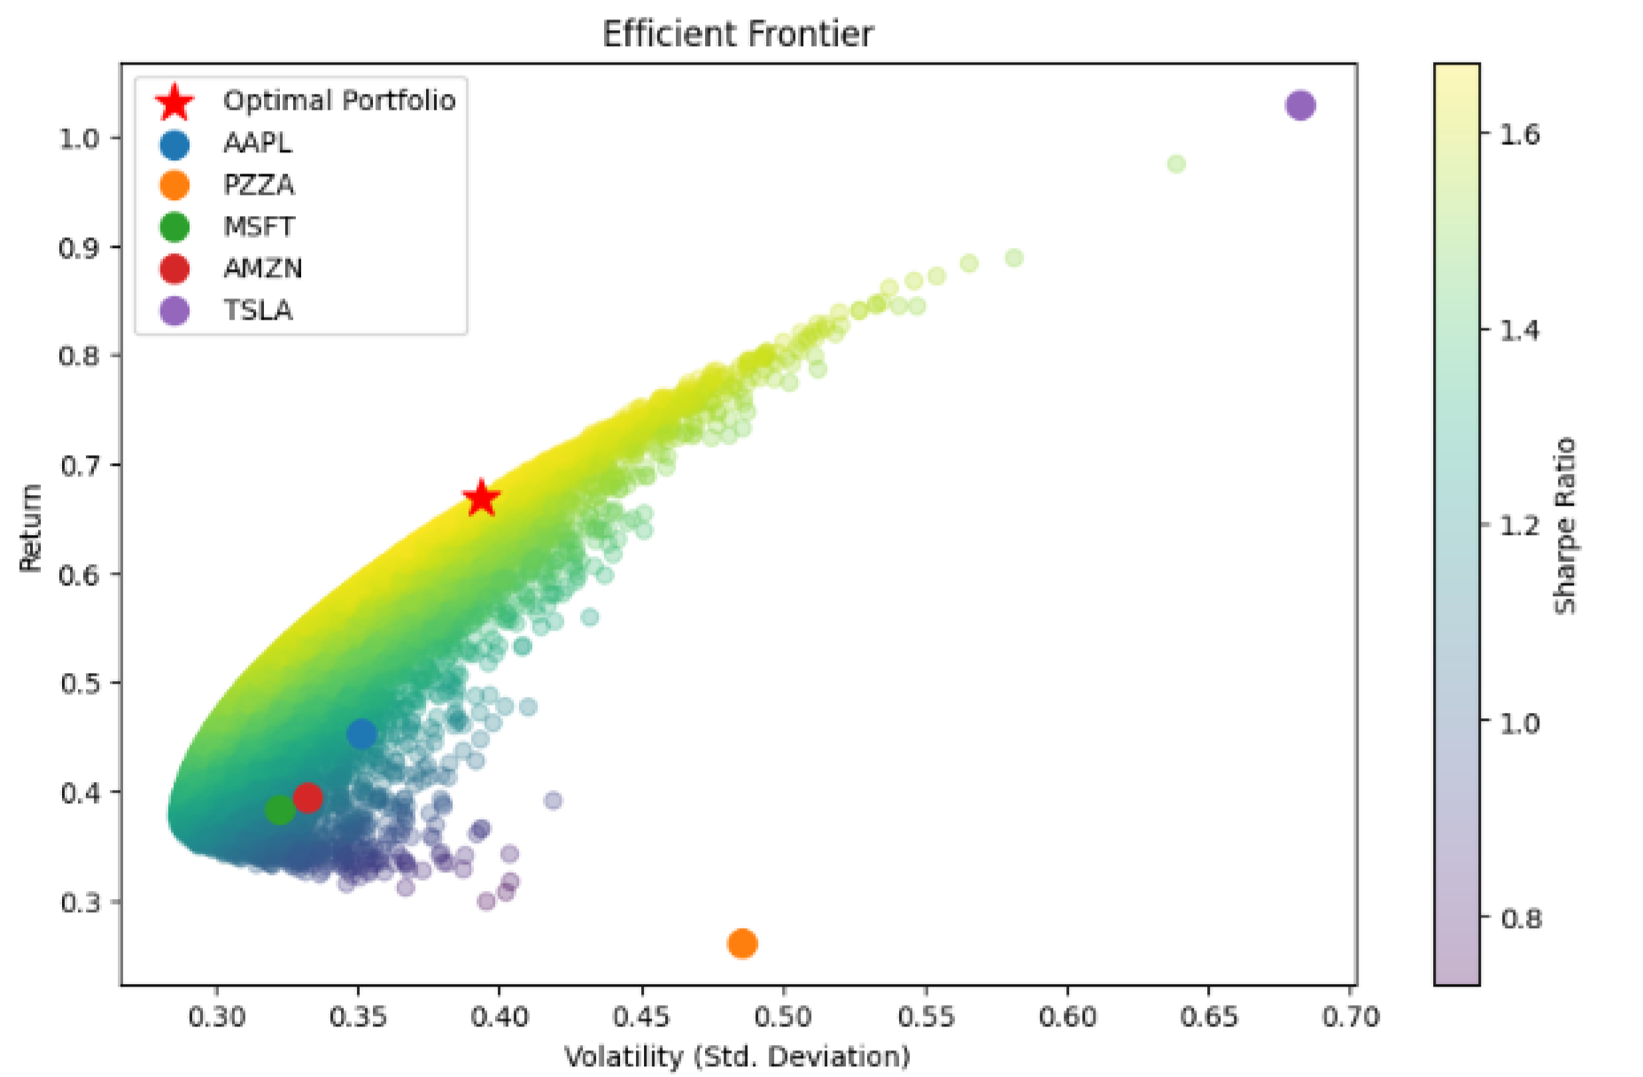

# Step 8 Result and Interpretation

Summarization of findings and interpretation:

For FF3 and FF5, the R-squared values of 0.689 (FF3) and 0.701 (FF5) are suggesting that both models explain a substantial portion of the portfolio's variance and is explained by the 3 factors Market, size and value. All in all, based on FF3 and FF5 model interpretations on 5 stocks, a strong market dependency of the portfolio shown, a preference for growth over value stocks, leaning towards companies with aggressive investment strategies.

Interpretation from step 7 results:

1. Market Risk Premium (Mkt-RF):
   1. FF3 Model Interpretation: A strong positive sensitivity of the portfolio returns to the market, with a beta of 1.1080. Portfolio is moving with the overall market significantly.
   2. FF5 Model Interpretation: Value remained high (Coefficient: 1.0526 ) and positive, strong correlation with the market. With a slightly lower beta compared to FF3 model.
2. Size Factor (SMB)
   1. FF3 Model Interpretation: Small Minus Big, the coefficient of 0.1849 showing a positive relationship with small-cap stocks.
   2. FF5 Model Interpretation: SMB coefficient is still positive but smaller (0.0833) than in the FF3 model (0.1849), indicating a smaller lean or tilt towards smaller companies.
3. Value Factor (HML)
   1. FF3 Model Interpretation: Negative value of coefficient of -0.5850 shows a strong preference for growth stocks vs. Value stocks
   2. FF5 Model Interpretation: Coefficient continued to be negative, -0.4656 showing a strong preference for growth over value stocks
4. Profitability Factor (RMW)
   1. FF5 Model Interpretation: Though the coefficient is positive value of 0.1159, p-value is 0.255 which is not that significant (statistically) This is indicating profitability is not heavily influencing the portfolio but slight tilt towards companies with profitability(robust)
5. Investment Factor (CMA)
   1. FF5 Model Interpretation: The coefficient is negative of -0.747035 and is significant, showing a preference for companies with more investment strategies that are aggressive

# References

Aharony, Joseph, and Itzhak Swary. "Quarterly dividend and earnings announcements and stockholders' returns: An empirical analysis." The Journal of finance 35.1 (1980): 1-12.

Arditti, Fred D. "Risk and the required return on equity." The Journal of Finance 22.1 (1967): 19-36.

Boudt, Kris, Wanbo Lu, and Benedict Peeters. "Higher order comments of multifactor models and asset allocation." Finance Research Letters 13 (2015): 225-233.

Chen, Nai-Fu, Richard Roll, and Stephen A. Ross. "Economic forces and the stock market." Journal of business (1986): 383-403.

Fama, Eugene F., and Kenneth R. French. "Size and book‐to‐market factors in earnings and returns." The journal of finance 50.1 (1995): 131-155.

Fama, Eugene F., and Kenneth R. French. "Multifactor explanations of asset pricing anomalies." The journal of finance 51.1 (1996): 55-84.

Kumar, Muneesh, and Sanjay Sehgal. "Company characteristics and common stock returns: The Indian experience." Vision 8.2 (2004): 33-45.

"Fama French Three Factor Model Explained Essentials of Investments Course. CFA Exam" YouTube, Farhat Lectures, 22 July 2021, [https://www.youtube.com/watch?v=6](https://www.youtube.com/watch?v=)I9dqE-Wy-g

L’Her, Jean-François, Tarek Masmoudi, and Jean-Marc Suret. "Evidence to support the four-factor pricing model from the Canadian stock market." Journal of International Financial Markets, Institutions and Money 14.4 (2004): 313-328.

Mhiri, Maroua, and Jean-Luc Prigent. "International portfolio optimization with higher moments." International Journal of Economics and Finance 2.5 (2010): 157-169.

Michaud, Richard O., and Robert Michaud. "Estimation error and portfolio optimization: a resampling solution." Available at SSRN 2658657 (2007).

Rustem, Berç. "Computing optimal multi-currency mean-variance portfolios." Journal of Economic Dynamics and Control 19.5-7 (1995): 901-908.